THE MAN BEHIND BLACK HISTORY MONTH

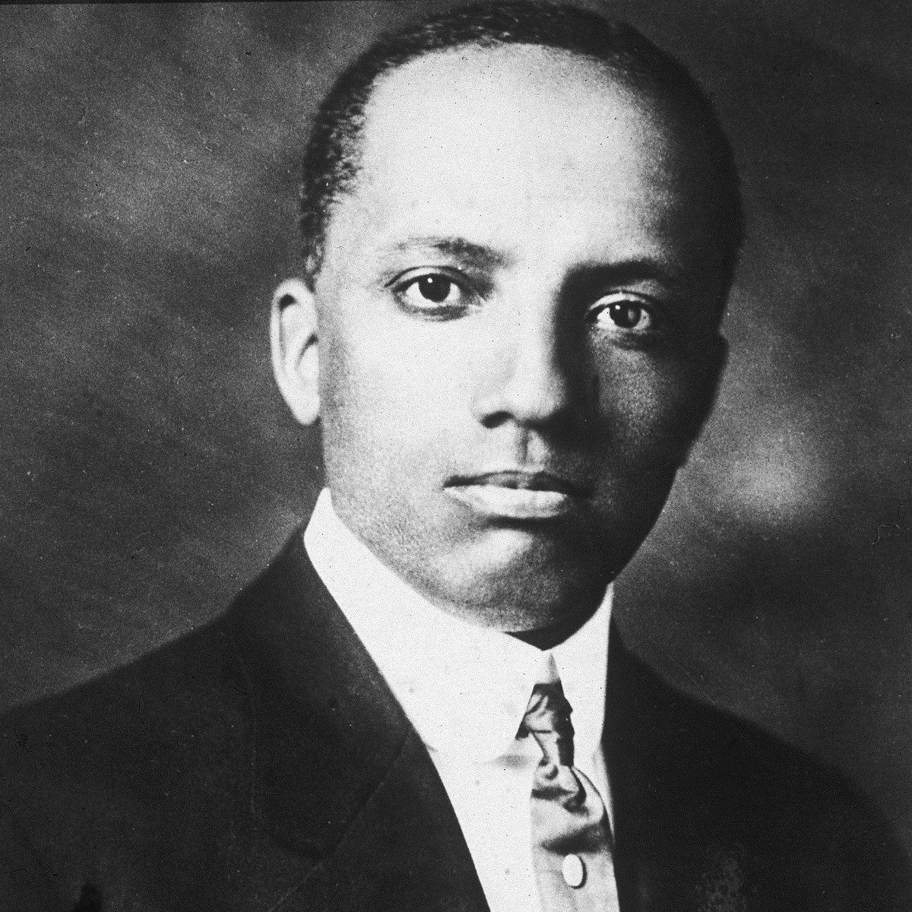
1875-1950
In 1915, Carter G. Woodson traveled to Chicago from his home in Washington, D.C. to take part in a national celebration of the 50th anniversary of emancipation. He had earned his bachelor’s and master’s degree at the University of Chicago, and still had many friends there. As he joined the thousands of Black Americans overflowing from the Coliseum, which housed exhibits highlighting African American achievements since the abolition of slavery, Woodson was inspired to do more in the spirit of celebrating Black history and heritage. Before he left Chicago, he helped found the Association for the Study of Negro Life and History (ASNLH). A year later, Woodson singlehandedly launched the Journal of Negro History, in which he and other researchers brought attention to the achievements of Black Americans.
Born in 1875 in New Canton, Virginia, Woodson had worked as a sharecropper, miner and various other jobs during his childhood to help support his large family. Though he entered high school late, he made up for lost time, graduating in less than two years. After attending Berea College in Kentucky, Woodson worked in the Philippines as an education superintendent for the U.S. government. He earned his bachelor’s and master’s degrees at the University of Chicago before entering Harvard. In 1912, three years before founding the ASNLH, he became only the second African American (after W.E.B. DuBois) to earn a doctorate from that institution.
Like DuBois, Woodson believed that young African Americans in the early 20th century were not being taught enough of their own heritage, and the achievements of their ancestors. To get his message out, Woodson first turned to his fraternity, Omega Psi Phi, which created Negro History and Literature Week in 1924. But Woodson wanted a wider celebration, and he decided the ASNLH should take on the task itself.
In February 1926, Woodson sent out a press release announcing the first Negro History Week. He chose February because the month contained the birthdays of both Abraham Lincoln and Frederick Douglass, two prominent men whose historic achievements African Americans already celebrated. (Lincoln’s birthday was February 12; Douglass, a former slave, hadn’t known his actual birthday, but had marked the occasion on February 14.)
As schools and other organizations across the country quickly embraced Woodson’s initiative, he and his colleagues struggled to meet the demand for course materials and other resources. The ASNLH formed branches all over the country, though its national headquarters remained centered in Woodson’s row house on Ninth Street in Washington D.C. The house was also home base for the Associated Publishers Press, which Woodson had founded in 1921.
Article by: Library of Congress (Sarah Pruitt)
Carter G. Woodson, circa 1910.
Hulton Archive/Getty Images
READ MORE: Black History Facts
The author of more than 20 books, including A Century of Negro Migration(1918), The History of the Negro Church (1921), The Negro in Our History (1922) and his most celebrated text, The Mis-Education of the Negro (1933), Woodson also worked in education, as principal for the Armstrong Manual Training School in Washington, D.C., and dean at Howard University and the West Virginia Collegiate Institute.
Clearly, Woodson never viewed the study of Black history as something that could be confined to a week. As early as the 1940s, efforts began to expand the week of public celebration of African American heritage and achievements into a longer event. This shift had already begun in some locations by 1950, when Woodson died suddenly of a heart attack at home in Washington.
With the rise of the civil rights and Black Power movements in the 1960s, young African Americans on college campuses were becoming increasingly conscious of the historic dimension of their experience. Younger members of the ASNLH (which later became the Association for the Study of African American History) urged the organization to change with the times, including the official shift to a month-long celebration of Black history. In 1976, on the 50th anniversary of the first Negro History Week, the Association officially made the shift to Black History Month.
Since then, every U.S. president has issued a proclamation honoring the spirit of Black History Month. Gerald Ford began the tradition in 1976, saying the celebration enabled people to “seize the opportunity to honor the too-often neglected accomplishments of Black Americans in every area of endeavor throughout our history.” Ronald Reagan’s first Black History Month proclamation stated that “understanding the history of Black Americans is a key to understanding the strength of our nation.”
In 2016, Barack Obama, the nation’s first Black president, made his last proclamation in honor of Woodson’s initiative, now recognized as one of the nation’s oldest organized celebrations of history. “As we mark the 40th year of National African American History Month, let us reflect on the sacrifices and contributions made by generations of African Americans, and let us resolve to continue our march toward a day when every person knows the unalienable rights to life, liberty, and the pursuit of happiness.”

